**Results**

**Item Response (IRT) Analysis**

The assumption of unidimensionality for Psychopathy was supported, as only one component exceeded the eigenvalues derived from simulated data, indicating the presence of a single meaningful factor (Figure 1). In contrast, the unidimensionality assumption was not supported for Narcissism and Machiavellianism, given that multiple components exceeded the simulated data threshold, suggesting the potential presence of more than one underlying factor for these constructs. These findings suggest that Psychopathy may be best represented as a unidimensional construct, whereas Narcissism and Machiavellianism appear to reflect two-dimensional structures.

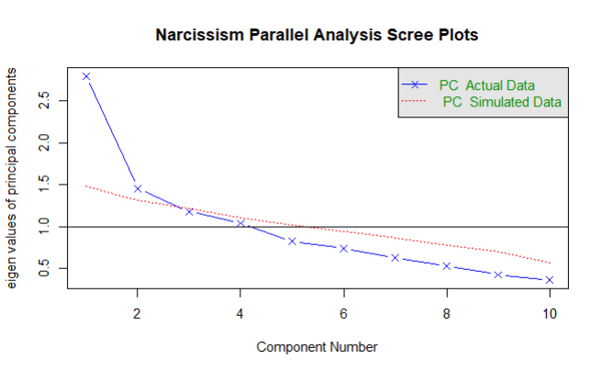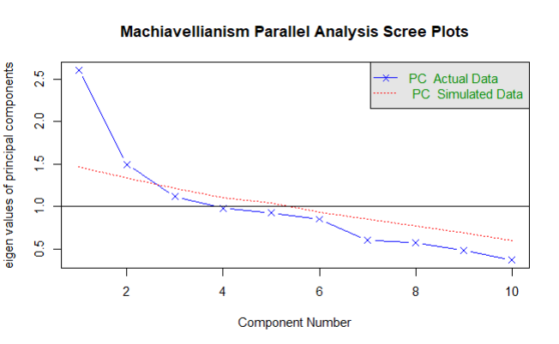

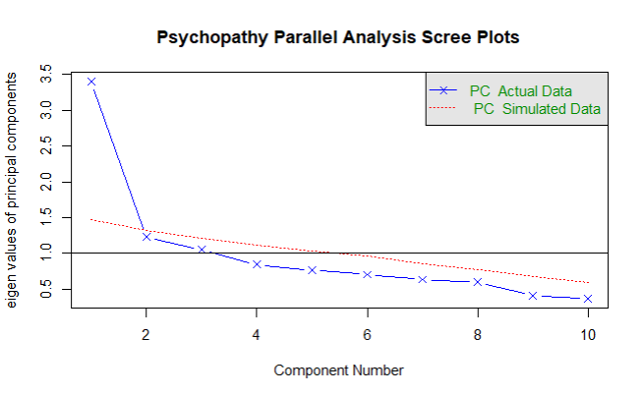

*Figure 1.* Parallel Analysis Scree Plots per dimension.

For all dimensions, the unconstrained models, which allow discrimination parameters to vary, demonstrated significantly better fit to the data compared to the constrained models in which discrimination parameters were held equal (Table 1). Thus, the assumption of equality of discrimination parameters was not tenable for any of these dimensions.

*Table 1.* Likelihood ratio tests

|  |  |  |  |  |  |  |
| --- | --- | --- | --- | --- | --- | --- |
|  | **AIC** | **BIC** | **Log Likelihood** | **LRT** | **df** | **p-value** |
| Constrained Narcissism | 3453.02 | 3566.26 | -1685.51 |  |  |  |
| Unconstrained Narcissism | 3366.98 | 3505.09 | -1633.49 | 104.03 | 9 | <.001 |
| Constrained Machiavellianism | 3420.44 | 3533.69 | -1669.22 |  |  |  |
| Unconstrained Machiavellianism | 3350.96 | 3489.07 | -1625.48 | 87.48 | 9 | <.001 |
| Constrained Psychopathy | 3113.62 | 3224.11 | -1516.81 |  |  |  |
| Unconstrained Psychopathy | 2993.91 | 3129.26 | -1447.96 | 137.71 | 9 | <.001 |

For Narcissism and Machiavellianism, the test provided the most information in the middle range of the trait (around -2 to 2), meaning it provides more information for people with moderate levels of these traits (Figure 2). For Psychopathy, the test had lower information for negative ability levels but increased sharply and remained informative at higher levels. This suggests the test is better at measuring moderate to high levels of Psychopathy rather than low levels.

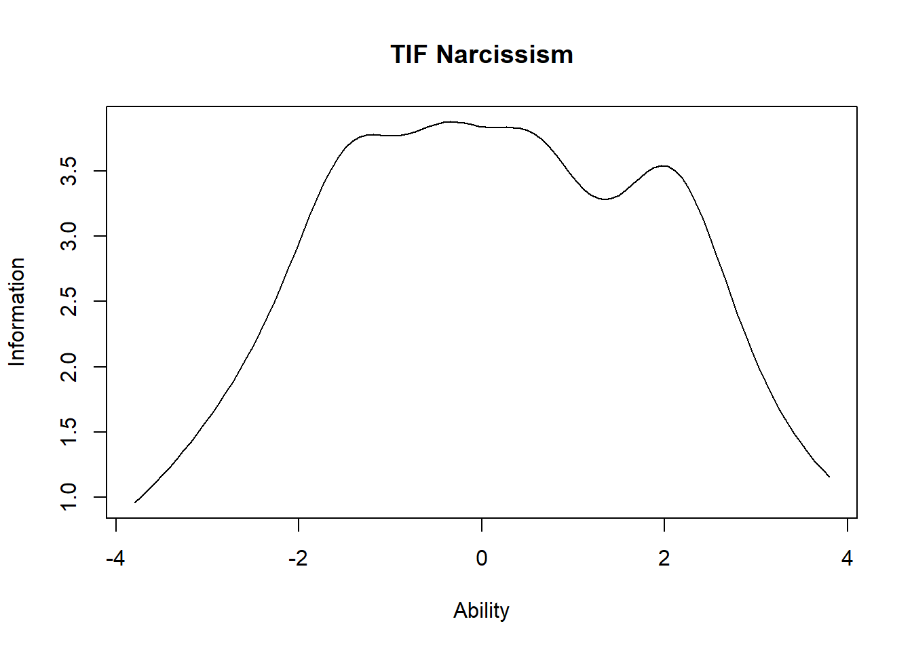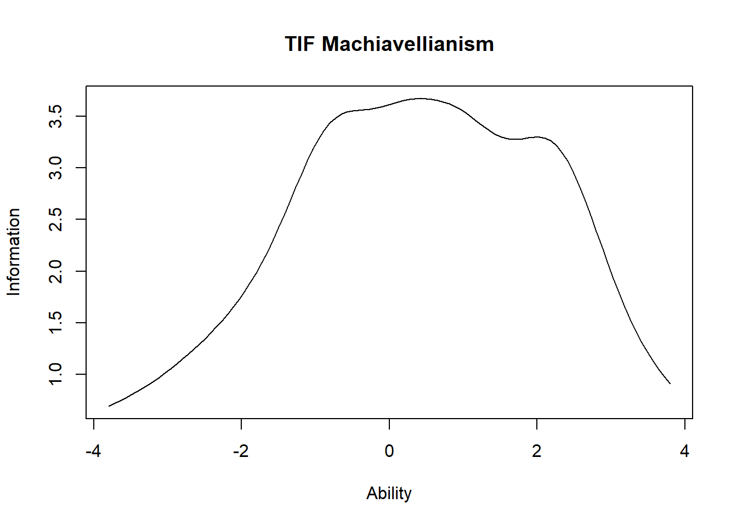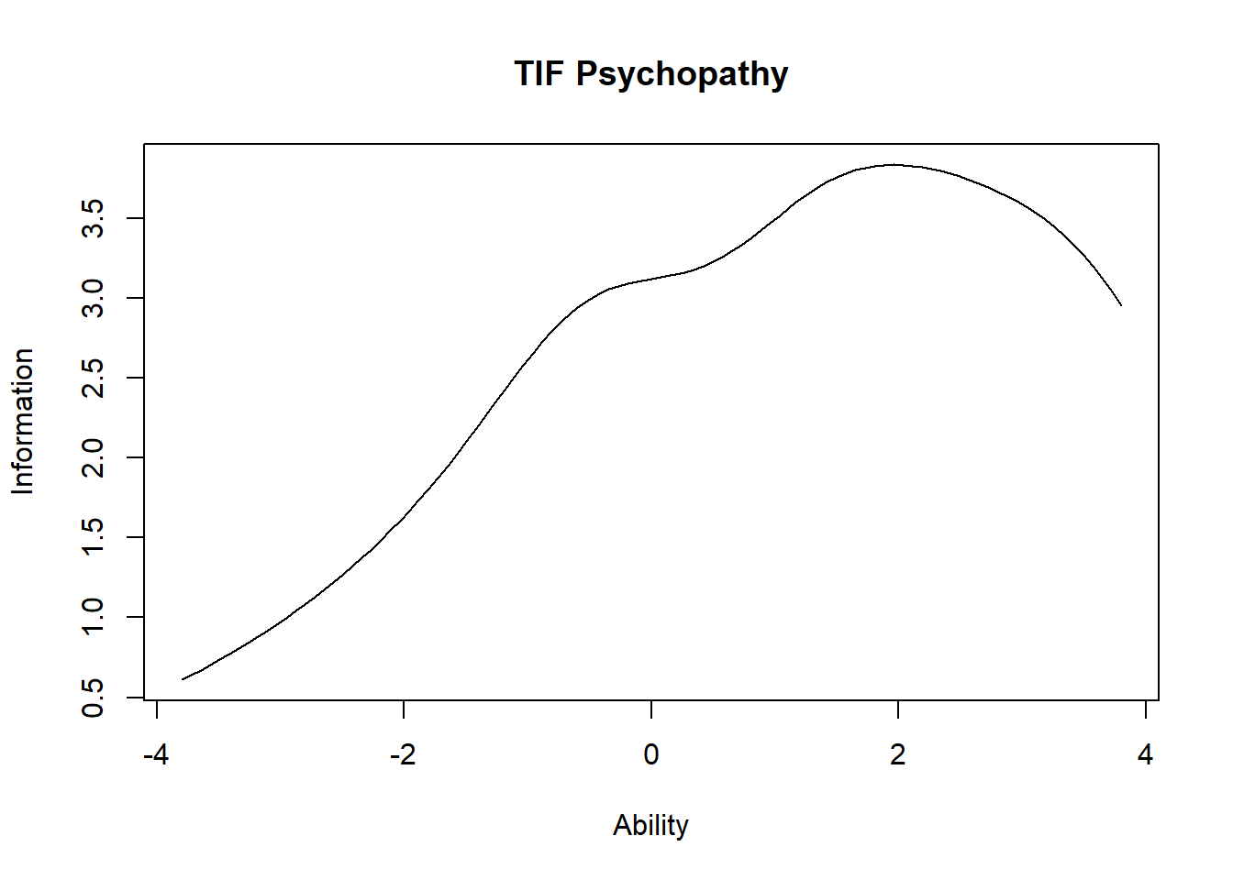

*Figure 2.* Test Information Function per dimension.

Many well-designed items were identified as their corresponding discrimination parameters (a) and item-rest correlations (r) were high (Table 2, Table 3). Item 1 (“I was born to be a leader”) has item discrimination of 2.479 indicating great performance in distinguishing between those with high and low Narcissism. Such a statistic of item 17 (“I tend to remember what people tell me, in case I can use it later”) is 1.583. Item 23 (“I frequently behave impulsively”) has an item-rest correlation of 0.3 showing high consistency with this dimension itself.

Based on the selected cut-off points, Q2 (a = 0.023, r = 0.15), Q6 (a = 0.233, r = 0.024), Q13 (a = 0.208, r = 0.056), Q16 (a = -0.083, r = 0.086), Q18 (a = -0.343, r = 0), Q19 (a = 0.620, r = 0.057), and Q20 (a = -0.439, r = -0.062) were removed. Item information functions of these items supported the exclusion (Appendix B).

After analysing the removed items, several explanations were provided to account for the poor performance of the removed items. Item 2 (“I have difficulty accepting compliments.”) seems to overlap with self-esteem and perceived vulnerability. Item 6 (“People with talents should show them off”) might not strongly reflect Narcissism as it relates to a general belief about self-expression. These two items contradict with the definition of Narcissism which suggests a personal trait of self-importance or entitlement.

As for Machiavellianism, the core of this dimension is a manipulative or exploitative tendency. Item 13 (“Most people are gullible”) primarily reflects a general cynicism or distrust toward people rather than personal inclination to manipulate them. This is the same case with item 16 (“Most people are inherently kind”) that makes it less indicative of Machiavellianism as it pinpoints general perception of human nature. Regarding item 18 (“I easily forgive people”), it might not align with Machiavellianism because forgiveness involves a degree of emotional generosity and trust. Item 19 (“When I plan for the future, I prioritize my own well-being over others”) could be interpreted as a generally agreeable statement, as its phrasing may be seen as describing a sense of self-preservation, as opposed to opportunistic self advancement. Item 20 (“Everyone is inherently worthy of respect”) seems not to correlate with this dimension because it emphasizes judgment of others’ respectfulness rather than how useful they are.

*Table 2.* Item Discrimination Parameters.

|  |  |  |  |  |  |  |  |  |  |  |
| --- | --- | --- | --- | --- | --- | --- | --- | --- | --- | --- |
| **Dimension** | **Q1** | **Q2** | **Q3** | **Q4** | **Q5** | **Q6** | **Q7** | **Q8** | **Q9** | **Q10** |
| Narcissism | 2.479 | 0.023 | 1.379 | -0.854 | 1.029 | 0.233 | 0.554 | 0.776 | 1.291 | -0.878 |
| Machiavellianism | 0.784 | 0.869 | 0.208 | 2.347 | 1.478 | -0.083 | 1.583 | -0.343 | 0.620 | -0.439 |
| Psychopathy | 0.766 | -1.775 | 0.715 | -0.778 | 1.534 | -1.073 | 1.184 | 0.931 | 1.103 | 0.989 |

*Note.* The number of the question refers to the number of the item within the dimension. Therefore, “Q1” within Machiavellianism, for example, refers to item 11.

*Table 3.* Item-rest Correlation.

|  |  |  |  |  |  |  |  |  |  |  |
| --- | --- | --- | --- | --- | --- | --- | --- | --- | --- | --- |
| **Dimension** | **Q1** | **Q2** | **Q3** | **Q4** | **Q5** | **Q6** | **Q7** | **Q8** | **Q9** | **Q10** |
| Narcissism | 0.271 | 0.150 | 0.434 | -0.118 | 0.229 | 0.024 | 0.158 | 0.297 | 0.332 | -0.111 |
| Machiavellianism | 0.231 | 0.306 | 0.056 | 0.496 | 0.391 | 0.086 | 0.249 | 0.000 | 0.057 | -0.062 |
| Psychopathy | 0.183 | -0.368 | 0.300 | -0.174 | 0.198 | -0.225 | 0.154 | 0.321 | 0.196 | 0.281 |

*Note.* The number of the question refers to the number of the item within the dimension. Therefore, “Q1” within Machiavellianism, for example, refers to item 11.

Cronbach’s Alpha values were above 0.6 for all traits, which indicates moderate internal consistency (Table 4). This suggests that test items might be cohesive to some extent. GLB values were noticeably higher. Psychopathy had the highest reliability (α = 0.698, GLB = 0.780), meaning that the test is slightly more reliable for measuring this trait compared to others. As for the revised dimensions whose items were dropped, GLB values were lower, however the values of Cronbach's Alpha for both were improved by more than 0.5. Hence, the removal of certain items led to a significant improvement in these statistics, showing better internal consistency.

*Table 4.* Classical test theory Reliability estimate

|  |  |  |  |  |  |
| --- | --- | --- | --- | --- | --- |
|  |  | **Before removal** |  | **After removal** | |
|  | **Narcissism** | **Machiavellianism** | **Psychopathy** | **Narcissism** | **Machiavellianism** |
| Cronbach’s Alpha | 0.619 | 0.605 | 0.698 | 0.670 | 0.679 |
| GLB | 0.783 | 0.749 | 0.780 | 0.767 | 0.725 |

**Factor Analysis**

Theoretical model was fitted (Dark Triad) and modification indices were estimated for this model (Table 5). Result was that the highest MI value, 16.529, indicated a cross-factor loading between Narcissism and item 28. The model was then adjusted accordingly (Revised Dark Triad 1). Following this adjustment, such analysis was performed again for the new model. The highest MI value for Revised Dark Triad 1 was 14.919, suggesting a residual covariance between item 5 and item 15. This relationship was added (Revised Dark Triad 2). Such a model was assessed for any significantly high MI. Another residual covariance was found between item 4 and item 10 (MI=14.379). Revised Dark Triad 3 was fitted by adding a new residual covariance into the previous model. No additional modification was needed afterwards as the global fit was good and there were no extremely large modification indices found.

Based on absolute fit measures (RMSEA), these models showed acceptable fit, except for Revised Dark Triad 3 showing good fit. Based on absolute and comparative fit measures, this model fits data best (χ2 = 287.830, RMSEA = 0.049, CFI = 0.871, TLI = 0.854, BIC = 7930.140, AIC = 7786.507).

*Table 5.* CFA Model Fit

|  |  |  |  |  |  |  |  |  |  |
| --- | --- | --- | --- | --- | --- | --- | --- | --- | --- |
| **Model** | **Description** | **Chi-square**  **χ2** | **df** | **nParameters** | **RMSEA** | **CFI** | **TLI** | **BIC** | **AIC** |
| Dark Triad | Three-factor Model | 336.724 | 227 | 49 | 0.064 | 0.778 | 0.753 | 7964.748 | 7829.401 |
| Revised Dark Triad 1 | Three-factor Model with cross-loading Narcissism and Q28 | 319.272 | 226 | 50 | 0.059 | 0.811 | 0.789 | 7952.058 | 7813.949 |
| Revised Dark Triad 2 | Three-factor model with cross-loading and residual covariance between Q5 and Q15 | 302.677 | 225 | 51 | 0.054 | 0.843 | 0.823 | 7940.226 | 7799.355 |
| Revised Dark Triad 3 | Three-factor model with cross-loading and 2 residual covariances (Q5 vs. Q15; Q4 vs. Q10) | 287.830 | 224 | 52 | 0.049 | 0.871 | 0.854 | 7930.140 | 7786.507 |

RMSEA of these models are below 0.08, showing acceptable fit (Table 6). However, models with 2, 3, 4, and 5 factors did not differ significantly from the data (p > .01). Additionally, 4-factor, and 5-factor models fit better than the 3-factor model. Therefore, 3-factor, 4-factor, and 5-factor models are selected. Factor structures of these models were then assessed, and the 5-factor model had the most meaningful structure.

*Table 6.* EFA Model Fit

|  |  |  |  |  |  |
| --- | --- | --- | --- | --- | --- |
| **nFactor** | **Chi-square χ2** | **df** | **p-value** | **RMSEA** | **BIC** |
| 1 | 358.033 | 230 | <0.000001 | 0.068 | -737.268 |
| 2 | 256.518 | 208 | 0.0123 | 0.043 | -734.015 |
| 3 | 205.463 | 187 | 0.1687 | 0.028 | -685.064 |
| 4 | 162.850 | 167 | 0.5763 | 0.000 | -632.434 |
| 5 | 132.878 | 148 | 0.8083 | 0.000 | -571.924 |

The first factor in the 5-factor model, consisting of items 4 and 10, describes a person's modesty. The second factor, consisting of items 11, 12, 14, 17, 23, 27 and 30, describes tactical dishonesty. Factor three, consisting of items 1, 3, 8, 9, 21 and 28, depicts the person’s hubris. Factor four, consisting of items 22, 24, 25,26 and 29, whereby items 22, 24 and 26 are reverse coded, shows a person’s lack of empathy. Finally, factor five, consisting of items 5, 7 and 15, reflects a person's perspective on their own importance in social situations.

In terms of dark triad vocabulary, factor 2, described as tactical dishonesty, could be considered as Machiavellianism (Jones & Paulhus, 2014). A lack of empathy could be considered psychopathic (Viding et al., 2014), hence, factor 5 could be regarded as measuring Psychopathy. Factors 1, 3 and 5 all describe traits relating to Narcissism, but are separated by the EFA. This may suggest that modesty (or lack thereof), hubris, and a participants perceived importance in social situations are all separate parts of Narcissism that are not strongly interrelated. This is in line with other studies that have found a three factor model to be much more fitting than a one-factor model for Narcissism (Crowe et al., 2019).

**References**

Crowe, M. L., Lynam, D. R., Campbell, W. K., & Miller, J. D. (2019). Exploring the structure of narcissism: Toward an integrated solution. *Journal of Personality, 87*(6), 1151–1169.https://doi.org/10.1111/jopy.12464

Furr, R.M. (2021) Psychometrics: An introduction. 4th Edition, SAGE Publications.

Jones, D. N., & Paulhus, D. L. (2014). Introducing the Short Dark Triad (SD3): A brief measure of dark personality traits. *Assessment*, *21*(1), 28–41. https://doi.org/10.1177/1073191113514105

Likert, R. (1932). A Technique for the Measurement of Attitudes. Archives of Psychology, 140, 1–55.

Paulhus, D. L., & Williams, K. M. (2002). The Dark Triad of personality: Narcissism, Machiavellianism, and psychopathy. *Journal of Research in Personality*, *36*(6), 556–563. https://doi.org/10.1016/S0092-6566(02)00505-6

Qualtrics Inc. (2005). Qualtrics. Qualtrics, Provo, UT

RStudio Team (2020). RStudio: Integrated Development for R. RStudio, PBC, Boston, MA

Viding, E., McCrory, E., & Seara-Cardoso, A. (2014). Psychopathy. *Current Biology, 24*(18), R871-R874.https://doi.org/10.1016/j.cub.2014.06.055